Unlooping of electricity supplies for installation of low carbon technologies
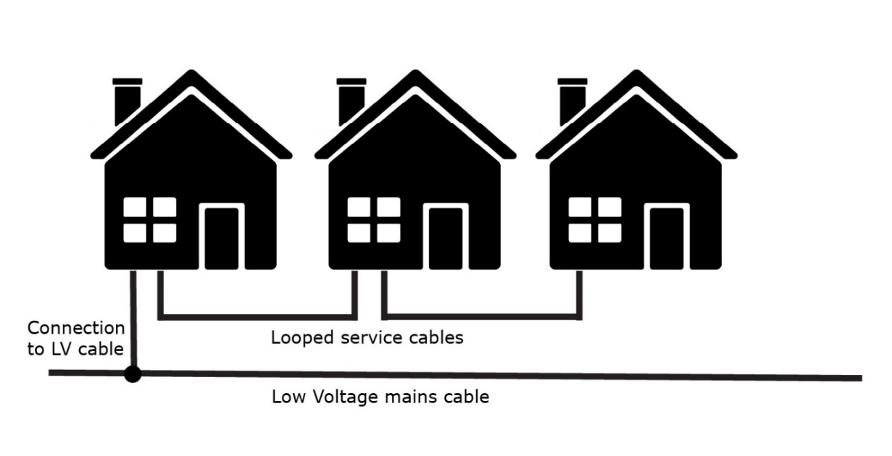
Report summary
Looped electricity supplies were a cheaper way to add homes to the local electricity distribution network. This was common, particularly for socially rented homes from about the 1950s to the 1980s/90s, with semi-detached and terraced homes on new estates often with gas heating. There is a single connection from the main low voltage service cable in the street to the first property. The mains cable was then ‘looped’ from the first property to the next and beyond to provide their electricity connections. The looped supply may cover between two and four homes, often with a 100A supply shared between the properties.
The report investigates how looped electricity supplies are limiting installation of low carbon technologies, particularly in social housing. There are case studies based around installation programmes for Energise Barnsley, Together Housing along with further landlords in the north and south of England. Recommendations are provided suggesting how to address issues associated with looped supplies and to improve the rate of connections of low carbon technologies to homes with these connections.

