NEA conference exhibition prospectus

WHERE AND WHEN?

Date: 4 to 6 December 2023

Venue: Leicester Tiger Stadium
Leicester

SHELL SCHEME DIMENSIONS

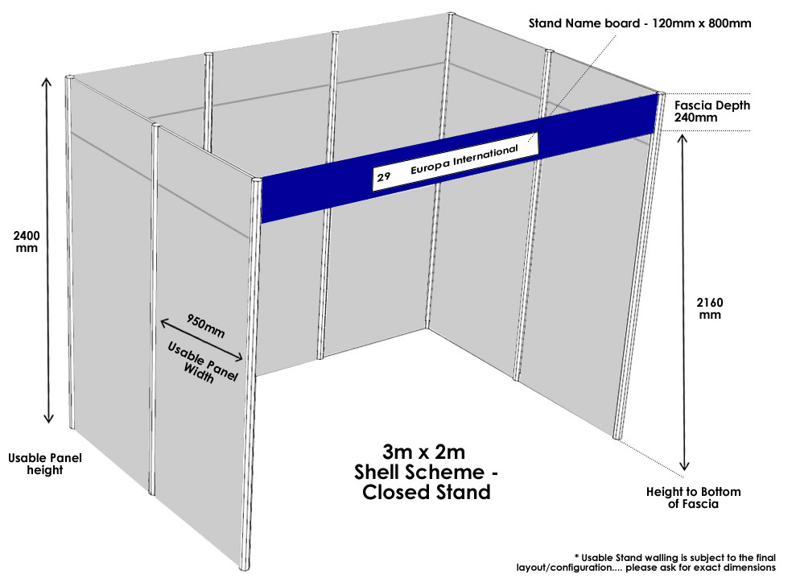

Each unit is a shell scheme measuring 3m x 2m, comprising a back wall and, if appropriate, side partitions of Velcro-compatible grey material. (Corner/end of row stands will normally have one of their side partitions removed unless requested not to). The exhibitor's name is displayed in black lettering across the fascia.

COST OF EXHIBITING

EXHIBITION FEES
NEA Business Supporters Group member (Tiers 1, 2 & 3) | FREE*
NEA Business Supporters Group member (Tier 4 & introductory) | £800 + VAT
BSG additional stand (to make a double 6m x 2m stand) | £800 + VAT
NEA Members | £650 + VAT
All Non-members | £1,000 + VAT

WHAT IS INCLUDED IN THE EXHIBITION FEE?

- One 3m x 2m exhibition stand
- One delegate place for the person staffing your stand, which includes:
  - Full access to the full conference and social programme
  - Wine reception and buffet on Monday 4 December
  - Networking dinner on Tuesday 5 December
  - Lunch and refreshments at designated times on Tuesday and Wednesday

The exhibition will open at 4pm on Monday 4 December followed by the official opening at 6pm. The exhibition will close after the final session on Wednesday 6 December.

What is the cost to send additional delegates?

Please see the booking form attached to this prospectus.

ADDITIONAL INFORMATION

Who attends the NEA conference?

Last year conference was attended by nearly 300 participants representing the fuel utilities, local and central government, consumer and caring agencies, energy service providers, manufacturers and installers of energy efficiency products and materials, and regional decision makers.

Conference social programme

A programme of activities complements the conference and exhibition including an evening buffet and drinks reception at the exhibition opening on Monday evening and networking dinner on Tuesday evening.

The benefits of exhibiting

- The exhibition provides an excellent opportunity to promote your organisation’s products and services and/or objectives to a diverse range of participants throughout the conference.

- All exhibitors are encouraged to attend the plenaries and seminars and participate fully in the conference. (The exhibition fee allows for one participant – the “stand manager” – to attend the conference and the sessions and all social events).

- Exhibitors are also welcome to participate in the social programme, which provides excellent networking opportunities.

- The exhibition is a focal point of the conference. The exhibition hall will host all the catering facilities, allowing delegates easy viewing access. Longer viewing slots and extended lunch breaks allow delegates plenty of viewing opportunities.

IMPORTANT - PLEASE NOTE

Stand numbers

The stand numbers used on the floor plan are for guidance only; please do not use these on any promotional material as your actual stand number may change.

Exhibition layout

Depending on final take-up of stands, NEA reserves the right to alter the layout of the exhibition, including the location of the catering points. We will inform you if we need to relocate your stand; we will endeavour to make the move minimal and keep your stand in the general location that you have requested.

The booking form is below:

COMPLETE AND RETURN THIS PAGE

EXHIBITION STAND BOOKING FORM

ORGANISATION NAME:

Please enter the organisation name as it should appear on your stand fascia

DO YOU REQUIRE AN ELECTRICAL SOCKET? YES NO

 | 1st choice |  | 2nd choice |  | 3rd choice
PREFERRED SITE:

You can check stand availability at www.nea.org.uk/2018floorplan. Please refer to the floor plan at the end of this document. Numbers on the floor plan are for reference only and may not reflect the number on the actual exhibition stand. If all of your choices have already been taken we will allocate you a stand as near as possible to one of those you have chosen. NEA reserves the right to alter the floor plan layout at any time.

STAND MANAGER DETAILS
This is the person who will staff your stand and take the free delegate place that comes with this booking.

Name:
Job title:
Organisation:
Address:
Post code:
Email address:
Telephone No:

PLEASE TICK WHICH OF THE FOLLOWING YOU WISH TO BE CATERED FOR

MON 4 DEC – Buffet & Wine reception
TUE 5 DEC – Lunch
TUE 6 DEC – Dinner
WED 7 DEC - Lunch

Do you have any dietary of facility requirements?

COMPLETE AND RETURN THIS PAGE ONLY IF BOOKING ADDITIONAL DELEGATES

ADDITIONAL DELEGATES BOOKING FORM

Please use this form if you wish to send additional delegates to conference. You may copy this page if you want to send more than 4 people.

PLEASE TICK THE DELEGATE RATE APPLICABLE TO YOUR ORGANISATION

DELEGATE 1

Name: |  |  | Please tick those you wish to be catered for:
Job title: |  |  |  | Mon 4 – Buffet
Organisation: |  |  |  | Tue 5 – Lunch
Email address: |  |  |  | Tue 5 – Dinner
Telephone No: |  |  |  | Wed 6 - Lunch
Diet/facility requirements:

DELEGATE 2

Name: |  |  | Please tick those you wish to be catered for:
Job title: |  |  |  | Mon 4 – Buffet
Organisation: |  |  |  | Tue 5 – Lunch
Email address: |  |  |  | Tue 5 – Dinner
Telephone No: |  |  |  | Wed 6 - Lunch
Diet/facility requirements:

DELEGATE 3

Name: |  |  | Please tick those you wish to be catered for:
Job title: |  |  |  | Mon 4 – Buffet
Organisation: |  |  |  | Tue 5 – Lunch
Email address: |  |  |  | Tue 5 – Dinner
Telephone No: |  |  |  | Wed 6 - Lunch
Diet/facility requirements:

COMPLETE AND RETURN THIS PAGE
PAYMENT DETAILS

Please tick the rate applicable to your organisation
EXHIBITION FEES
NEA Business Supporters Group member (Tier 1, 2 & 3) | FREE
NEA Business Supporters Group member (Tier 4 & introductory) | £800 + VAT
BSG additional stand purchase | £800 + VAT
NEA standard member | £650 + VAT
Non-member | £1,000 + VAT

Please tick the rate applicable to your organisation
DELEGATE FEES | Up to 30 September | From 1 October
NEA MEMBER: Local authority/not-for-profit | £280 + VAT | £308 + VAT
NEA MEMBER: Private sector | £358 + VAT | £396 + VAT
Non-Member: Local authority/not-for-profit | £382 + VAT | £418 + VAT
Non-Member Private sector | £468 + VAT | £518 + VAT

AMOUNT
1 x exhibition stand (3m x 2m) at the applicable rate above (includes Stand Manager)
x delegate places at the applicable rate above
Please invoice me for the total sum of (excluding VAT)
My purchase order number is

Name and address to send
invoice to:
Email address:

DELEGATE BOOKINGS: Cancellations notified on or before 30 September 2023 will receive a full refund. Cancellations notified between 1 October and 30 November 2023 will receive a 50% refund. Cancellations made from 1 December 2023 onwards, or in the case of a no-show at conference, will receive no refund.
EXHIBITION BOOKINGS: Cancellations notified on or before 31 October 2023 will receive a 75% refund. Cancellations on or after 1 November 2023 will receive no refund. By returning this booking form you agree to the cancellation terms and conditions. All cancellations must be by email to brian.hart@nea.org.uk. You will be given a cancellation number which should be quoted on any subsequent communication.

COMPLETE AND RETURN THIS PAGE

CONTRACTUAL AGREEMENT

- I agree to honour the TERMS AND CONDITIONS laid down on page 8 of this prospectus and Leicester Tigers health and safety rules and regulations.
- I confirm that the organisation holds adequate PUBLIC LIABILITY INSURANCE should the need arise to indemnify Leicester Tigers under the terms of the Exhibitors’ Booking Conditions.
- It is a condition of entry into the exhibition that every exhibitor complies with the MANAGEMENT OF HEALTH AND SAFETY AT WORK REGULATIONS 1999 and all legislation covering the venue. The exhibitor accepts that it is their legal and moral responsibility to ensure that their own and others’ health and safety is not put at risk by their actions/inactions during the event.
- I understand that the exhibition at the NEA conference is a private exhibition and that all visitors to the exhibition, other than the STAND MANAGER, must pay as conference participants. Failure to comply with this will be a potential breach to the terms and conditions of exhibiting.
- I understand that the company logo for the exhibition plan should arrive no later than Friday 10 November 2023. I also understand that logos received after this date may not be included in the plan and the organisation will be listed by name only.
- If you choose to return the completed Exhibition Stand & Stand Manager Booking Form and Contractual Agreement by email we will deem the document to have been authorised as if it had been signed by hand.
- This contract is a legally binding agreement.

Please sign here if returning authorised hard copy by post.

. . . . . . . . . . . . . . . . . . . . . . . . . . . . . . . . . . . . . . . . . . . . . . . . . . . . . . . . . . . . . . . . . . . . . . . . . . . .
Signature Date

Please type your name in the box below if returning electronic copy by email.

Please return electronic copy to brian.hart@nea.org.uk

Please return hard copy to:
Conference Team, NEA, Level 6, West One, Forth Banks, Newcastle upon Tyne NE1 3PA
Tel: 0191 261 5677
NEA is an independent charity, Registration No. 290511. Company limited by guarantee. Registered in England No. 1853927

TERMS AND CONDITIONS
- Each unit is a shell scheme measuring 3m x 2m comprising a back wall and, if appropriate, side partitions or Velcro-compatible grey material.
- The exhibitor’s name is displayed in black lettering across the fascia. The name will appear exactly as detailed on the booking form.
- Space will be allocated in date order of receipt of your booking form on a strict first-come-first-served basis.
- Exhibitors exhibit entirely at their own risk. NEA is not liable for any losses or damage to persons or property which the exhibitors may sustain.
- All exhibitors are required to adhere to Leicester Tigers’ health and safety rules and regulations.
- Any damage caused to the shell scheme or furniture will be the responsibility of the exhibitor and will be charged accordingly.
- Stand numbers. The stand numbers used on the floor plan are for guidance only; please do not use these on any promotional material as your actual stand number may change.
- Exhibition layout. Depending on final take-up of stands, NEA reserves the right to alter the layout of the exhibition, including the location of catering points. We will inform you if we need to relocate your stand and we will endeavour to make the move minimal and keep your stand in the general location that you have requested.

EXHIBITORS SHALL NOT

- Attach to the floors, shell scheme, furniture and fittings any nails, screws, hooks or other fitments. The use of Velcro is permitted.
- Bring in machinery without prior agreement.
- Use equipment that does not conform to the relevant safety standards.
- Use any electrical equipment that has not been tested for electrical safety and bears the appropriate test certificate.

SETTING UP AND BREAK DOWN

- Exhibitors will have access to the exhibition area from 12 noon on Monday 4 December. All stands must be set up by 4.00pm on Monday 4 December.
- Exhibitors may begin to dismantle their stands once the final session of the conference has begun on Wednesday 6 December.
- Further details, such as delivery access and car parking will be provided in the joining instructions once you have booked your stand.
CANCELLATION POLICY

DELEGATE BOOKINGS: Cancellations notified on or before 30 September 2023 will receive a full refund. Cancellations notified between 1 October and 30 November 2023 will receive a 50% refund. Cancellations made from 1 December 2023 onwards, or in the case of a no-show at conference, will receive no refund.
EXHIBITION BOOKINGS: Cancellations notified on or before 31 October 2023 will receive a 75% refund. Cancellations on or after 1 November 2023 will receive no refund. By returning this booking form you agree to the cancellation terms and conditions.

All cancellations must be by email to brian.hart@nea.org.uk. You will be given a cancellation number which should be quoted on any subsequent communication

You can check stand availability at
www.nea.org.uk/annual-conference-2023/exhibition

