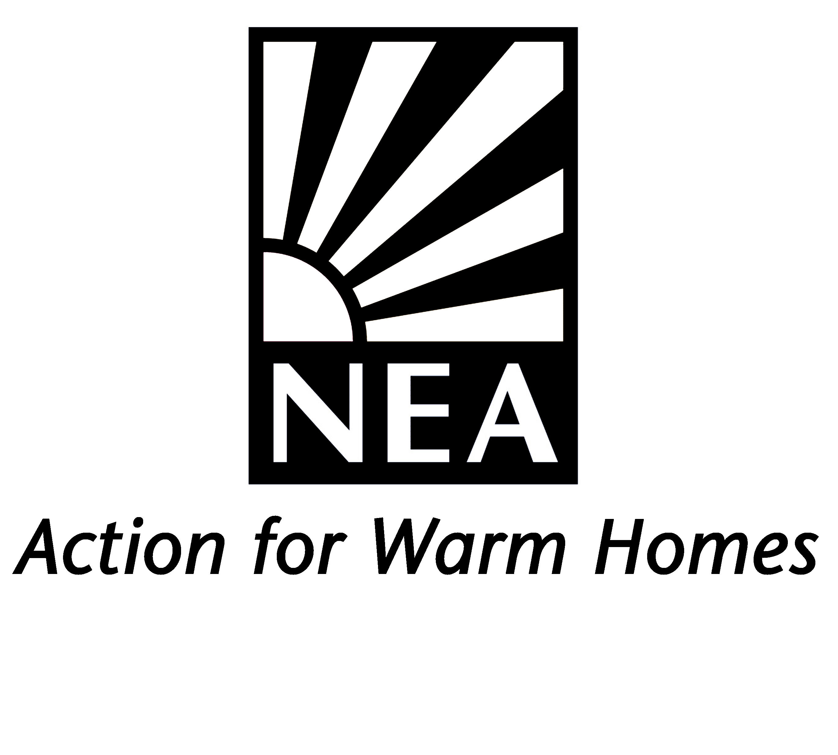

Energy Advisor (Coventry/West Midlands based)
Job Ref No: R01
Directorate of Operations

Job Details

Background information on NEA

NEA – the national energy charity

National Energy Action (NEA) is the national charity which works to eradicate fuel poverty and campaigns for greater investment in energy efficiency to help those who are poor or vulnerable to be able to stay affordably warm. NEA works in partnership with central and local government, fuel utilities, housing providers, consumer groups and voluntary organisations to promote energy efficiency with the aim of bringing social, environmental, housing and employment benefits to communities. NEA currently employs 85 staff at our national headquarters in Newcastle upon Tyne and in regional offices across England, Wales and Northern Ireland.

NEA achieves its objectives through:

- Developing and managing practical projects which demonstrate innovative ways of tackling fuel poverty and bringing the wider benefits of energy efficiency to communities.
- Carrying out research and analysis into the causes and extent of fuel poverty and the developing policies which address the problem.
- Providing advice and guidance on good practice in delivering energy efficiency services to low-income householder.
- Developing national qualifications and managing their implementation to improve the standards of practical work and the quality of energy advice.
- Campaigning to ensure social and environmental objectives are brought together under national energy efficiency programmes.

NEA is the leading national fuel poverty charity. Please visit our website at www.nea.org.uk to find out more about our work.

NEA’s Structure

NEA is governed by a Board of Trustees and headed up by its Chief Executive Officer. The Charity comprises of three distinct Directorates:
- Policy and Advocacy Directorate
- Directorate of Support Services
- Operations Directorate

The post of Energy Advisor sits within the Operations Directorate and reports to a Project Development Manager.

The Operations Directorate – delivering projects and services

NEA seeks to advise and support householders directly via a range of projects delivered by the Operations Directorate. Operations delivers a varied programme of work throughout England and Wales and is divided into two teams with broad responsibilities as set out below. Individual projects may have different objectives, but all aim to offer advice and support services directly to householders or to frontline staff working with vulnerable and fuel poor householders. The Directorate also delivers accredited training courses, income maximisation and technical services. Responsibilities of the two directorates are divided as follows:

Operations
Community Engagement and Demonstration (UK) | Skills, Standards and Delivery Mechanisms (UK)
- Warm and Safe Homes Advice Line  - Community Engagement  - Operational Partnerships  - Incomes Maximisation and Benefits Advice | - Training and Education  - Technical Services  - Project Design and Delivery  - Engagement with Smart Meter Roll Out

NEA obtains sponsorship and funding from a range of sources to enable the charity to meet its objectives to work with public, private and community sector partners to develop innovative projects which seek to establish good practice in bringing affordable warmth solutions to low income and vulnerable households. Lessons learned from project delivery are evaluated to inform NEA’s policy recommendations to central and local government, consumer bodies or other partners. The Operations Directorates consist of staff with a range of skills, including specialisms in community engagement and partnership development, technical understanding of energy efficiency measures, training delivery and skills development (including examination and assessment), fuel debt advice and the health impacts of fuel poverty.

About the post

NEA delivers energy advice and support directly to householders via our Warm and Safe Homes (WASH) helpline. Clients are initially triaged via the WASH helpline and those clients needing more in-depth support are referred through to an Energy Advisor. Most of our clients are vulnerable householders who are contacting the charity for a range of energy related advice matters and so our Energy Advisors need to be empathetic, polite and have good listening skills but also need to be knowledgeable and confident in order to provide support to clients, some of whom may be in difficult circumstances.

Whilst experience of providing advice to householders and knowledge of energy efficiency would be advantageous, NEA will provide full training to the successful candidate therefore empathy, confidence and an awareness of the issues facing vulnerable low-income households will be considered as priorities.

The post holder’s main responsibilities will be to provide one to one advice to clients referred through the WASH helpline as described above and also to deliver energy advice presentations to groups. In support of this, other tasks will also include:

- Provision of day-to-day support to our customers and partners (referral organisations)
- Processing, resolving or escalating client queries in line with the internal process.
- Development of referral pathways and identification of opportunities to deliver energy presentations
- Maintenance of appropriate client records and necessary data using client management systems to ensure the progress of work towards project targets is monitored and that project outcomes are fully recorded.

The post holder will be responsible for the delivery of services on a range of projects which will demonstrate good practice in delivery of affordable warmth for low income and vulnerable householders.

This post provides an exciting and rewarding opportunity to help the charity deliver its work programme and build its profile amongst regional stakeholders whilst developing and working on projects that bring social benefits and improvements to the well-being of low income and vulnerable householders whilst also meeting environmental goals.

NEA has been delivering programmes of energy advice work in Coventry and throughout the West Midlands.
We currently have an office base (with other staff) in Coventry and this would be the preferred location of the successful candidate. However, we are still working on a temporary remote basis. The Charity’s head office is in Newcastle upon Tyne. As NEA is a national charity, there is an expectation that delivery of project activity may also require periodic travel and occasional overnight stays throughout England.

Covid – 19
NEA continues to review and act on Government guidance to prioritise safe working conditions for all staff and therefore most of our staff are currently working from home. If a designated office base is agreed, temporary home working will be discussed with the post holder as appropriate to current and developing circumstances.

Term and Conditions of Employment

Salary: The salary range is Scale 5-6 (£23,023 - £28,065) FTE
Part – time salary is £13,814 - £16,839

Hours of work: 22.2 hours per week, Monday to Friday on a flexi-time basis.

Contract: This post is permanent.

Holidays: 25 days, plus 3 additional days in the Christmas/New year period, plus all public holidays per annum. Pro-Rata for Part Time hours

Pensions and other benefits: NEA offer a money-purchase, non-contributory pension scheme. 11½% of basic salary will be paid by NEA into the pension. NEA also offers death-in-service cover to state retirement age and enhanced sick pay.
As well as the above, NEA also offers: Flexible Working, Enhanced Family Friendly payments (e.g. Maternity, Paternity and Adoption Entitlements), Enhanced Sick Pay, Eye Test Payments, Bicycle Loans, Employee Assistance Programme.

Office: Coventry

Smoking: NEA has a firm “No Smoking” policy.

Interviews

Closing date for applications is Friday 27th May 2022. Interviews will be held online on Monday 6th June 2022.

Those shortlisted will receive confirmation of time of interview.

Application Procedures

Applications should be submitted on an NEA application form. Please quote reference number: R01. Use this form to detail why you are interested in the post, your qualifications, experience and any other relevant information. Unfortunately we are unable to accept CVs.

For an informal chat about this vacancy please contact NEA’s Director of Operations Peter Sumby on 07850 753698 or Lorraine Donaldson on 07714 294025.

Please email your completed application to: jobs@nea.org.uk.

Hard copies can be posted to The HR Team, National Energy Action, Level 6, West One, Forth Banks, Newcastle upon Tyne, NE1 3PA

NEA aims to be an equal opportunities employer. We welcome applications from any applicant who has the necessary skills and experience for the post.

JOB DESCRIPTION

Post: Energy Advisor
(Scale 5-6)

Responsible to: Project Development Manager

Project responsibilities will be allocated commensurate with the grade of the post holder

Responsibilities:

- To deliver the NEA work programmes for which the post holder has responsibility, commensurate with grade, to achieve outputs and outcomes as agreed with project funders.

- Provision of in depth one to one energy casework support for clients referred through the Charity’s advice line or via self-developed referral pathways.

- To identify opportunities to deliver energy presentations to community groups and the subsequent delivery of the presentations.

- Adherence to all call quality standards and all compliance requirements.

- Resolve or escalate client queries in line with internal processes.

- To update and maintain appropriate client records and necessary data using client management systems to ensure the progress of work towards project targets is monitored and that project outcomes are fully recorded.

- Undertake and record all follow up work to ensure all necessary actions are completed for recorded queries.

- Multitask between different work programmes and activities to support client and customer demand.

- Work with Project Development Managers as required to understand real time demand and establishment of priorities to ensure client needs are met.

- Maintain knowledge and understanding through a commitment to on-going development and learning.

- To contribute to the delivery of other NEA work programmes and projects as may be required.

- Any other duties that may be agreed from time to time.

Grade: Scale 5 – 6 V1.0/Dec 2021

PERSON SPECIFICATION

Energy Adviser
(Scale 5 to 6)

Candidates should meet the following requirements:

Essential Requirements

1 Awareness of the environmental, social and economic problems of deprived areas and the roles of the public, private and voluntary sectors in tackling them.

2 Self-motivation and the ability to work with limited supervision.

3 Excellent written and oral communication skills.

4 The ability to work with a wide range of people and experience of working with vulnerable householders, low income and/or other disadvantaged groups.

5 Tact and diplomacy when liaising with a wide range of organisations.

6 A reasonable level of numeracy.

7 Basic computing skills.

Desirable Requirements

1 Experience of project based work in the fields of energy efficiency, community development and regeneration, housing, health, social policy or consumer issues.

2 Knowledge of energy efficiency, particularly within the domestic sector. Knowledge of energy efficiency within community buildings would also be relevant.

3 Education to a degree level, equivalent qualifications, or relevant experience.

4 Knowledge of assistance available for energy efficiency improvements to low-income households.

5 Experience of the provision of advice to low-income households in energy efficiency or related fields.

6 Experience of the preparation and delivery of presentations.

