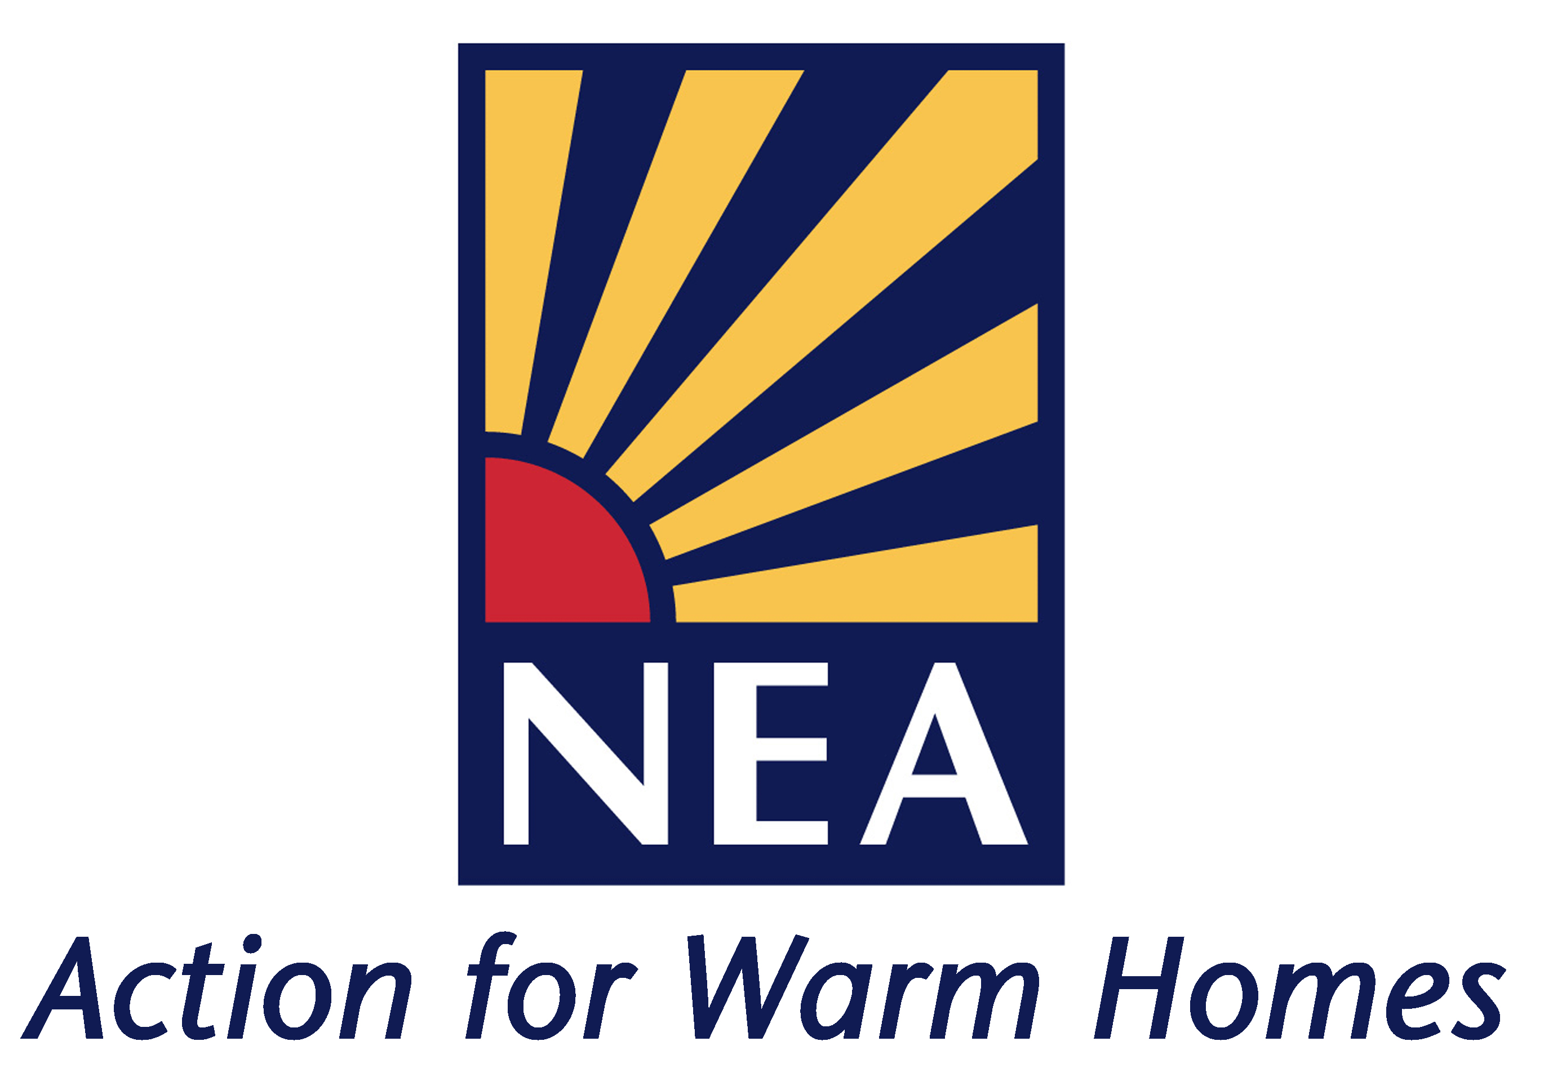

Parliamentary and Public Affairs Officer

JOB DETAILS

Background information on NEA

NEA – the national energy charity

National Energy Action (NEA) is the national charity which works to eradicate fuel poverty and campaigns for greater investment in energy efficiency to help those who are poor or vulnerable to be able to stay affordably warm. NEA works in partnership with central and local government, fuel utilities, housing providers, consumer groups and voluntary organisations to promote energy efficiency with the aim of bringing social, environmental, housing and employment benefits to communities. NEA achieves its objectives through:

- Developing and managing practical projects which demonstrate innovative ways of tackling fuel poverty and bringing the wider benefits of energy efficiency to communities.
- Carrying out research and analysis into the causes and extent of fuel poverty and the developing policies which address the problem.
- Providing advice and guidance on good practice in delivering energy efficiency services to low income householders.
- Developing national qualifications and managing their implementation to improve the standards of practical work and the quality of energy advice.
- Campaigning to ensure social and environmental objectives are brought together under national energy efficiency programmes.

NEA is the leading national fuel poverty charity. Please visit our website at www.nea.org.uk to find out more about our work.

NEA’s Structure and the role

NEA currently employs 78 staff at our national headquarters in Newcastle upon Tyne and in regional offices across England, Wales and Northern Ireland. NEA comprises of four Directorates. The post of Parliamentary and Public Affairs Officer will report to the Head of Policy and Public Affairs, within the newly established Policy and Advocacy Directorate which is responsible for Policy and Research, Public Affairs, Communications and wider external relations. NEA also has two Directorates of Operations (Skills, Standards & Delivery Mechanisms and Community Engagement & Demonstration), alongside Directorate of Support Services headed by Programme Director/Deputy Chief Executive. If successful you will help build political momentum across each of the UK nations we operate in so that ending fuel poverty is a great priority across the UK and national parliaments.

Terms and conditions of employment

Salary: The salary range £28,296 - £32,879 plus £3,300 London weighting if applicable. Pay award pending.

Hours of work: 37 hours per week, Monday to Friday on a flexi-time basis. Applicants must be willing to work away from home as required. In the event of work undertaken on evenings or weekends, and which may involve travel away from the office, time off in lieu of payment is given.

Holidays: 25 days, plus 3 additional days in the Christmas/New year period, plus all public holidays.

Pensions and other benefits: NEA offers a money-purchase, non-contributory pension scheme, and 11½% of basic salary will be paid by NEA into the pension. NEA also offers a death-in-service benefit scheme.

Office: The post is likely to be based at NEA’s London office however NEA have a flexible working policy and is considering further how greater flexibility regarding location and core hours could be more effective for NEA and our staff.

Post Status: Permanent

Coronavirus (COVID-19) NEA continues to review and act on Government guidance to prioritise safe working conditions for all staff.

Interviews

Interviews will be held by video conferencing during the week beginning 18 October. Those shortlisted will receive confirmation of the date and time of interview and any skills-based task that may be required as part of the interview process.

Application Procedures

Applications should be submitted on an NEA application form. Use this form to detail why you are interested in the post, your qualifications, experience and any other relevant information. CVs are not accepted.

For any information not contained within this job profile or an informal chat about this vacancy please contact Matt Copeland, Head of Policy and Public Affairs (matt.copeland@nea.org.uk).

The closing date for applications is Friday 15 October 2021 at 12 noon.

Please address your application to: Tracy Norris, Business Support Officer, National Energy Action, Level 6, West One, Forth Banks, Newcastle upon Tyne, NE1 3PA or email tracy.norris@nea.org.uk.

NEA aims to be an equal opportunities employer. We welcome applications from any applicant who has the necessary skills and experience for the post. We particularly welcome applications from disabled and Black, Asian and Minority Ethnic (BAME) candidates as BAME and disabled people are currently under-represented within NEA.

JOB DESCRIPTION

Post: Parliamentary and Public Affairs Officer

Responsible to: Head of Policy and Public Affairs

Responsibilities

- Provide the secretariat function for cross party groups at Westminster and Cardiff including identifying new officers, members and commercial supporters.

- Support NEA Vice-Presidents groups with briefings and updates on NEA advocacy.

- Working with colleagues, increase the profile and impact of NEA advocacy with parliamentarians, parliamentary committees and influential pressure groups.

- Support the profile of NEA at the main party-political and other conferences.

- Work with colleagues to identify priority political targets – national, regional and local - to support NEA strategic priorities.

- Work with the Head of Policy and Public Affairs to support internal policy and campaign meetings and sub-groups.

- Support with coordination of relevant campaign, coalition and partnership meetings across England, Wales and Northern Ireland.

- Monitoring of proceedings in the UK and devolved parliaments.

- Undertake other specific tasks relating to NEA policy and campaigns and other responsibilities as may be agreed from time to time.

Grade: Scale SO1-SO2 Ref: v2 May 21

Person Specification

REF: 1.1/Feb 11
Post: Parliamentary and Public Affairs Officer

Candidates should meet the following requirements

Essential

- Commitment to NEA’s mission to eradicate fuel poverty and for everyone to be able to afford to keep their homes warm and safe.

- Minimum of two years’ relevant experience within a third sector organisation, NGO, charity, lobby group, Parliament focussing on relevant policy area.

- Thorough understanding of parliamentary procedures and experience of engaging Parliamentarians.

- Experience writing concise and compelling briefings for parliamentarians and senior colleagues.

- Educated to degree level or relevant experience.

- You will be motivated more by achieving impact and change than by the intricacies of parliamentary procedure.

- You will have experience of working directly with parliamentarians and their staff and in the ways and workings of the UK parliament.

- Ability to maintain political impartiality and be discreet.

Desirable

- You may have experience of working in the Senedd or Northern Ireland Assembly.

